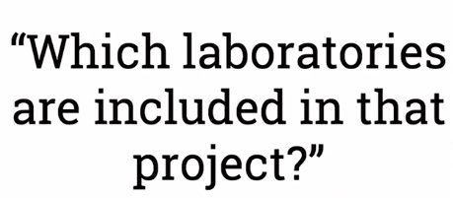

World Wide Web

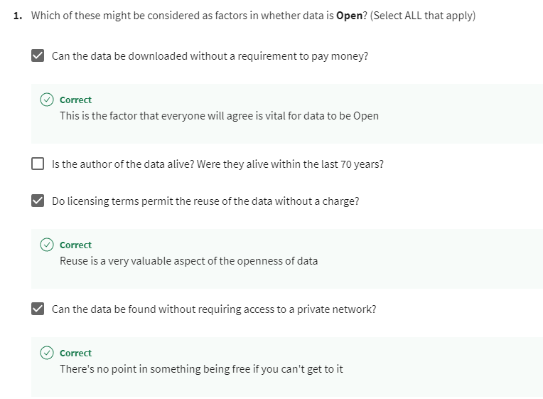

## Reading linked data

Resource Description Framework -> Linked data model, It's a framework for describing information, in a way that is simple and allows us to build more complicated structures out of simple structures.

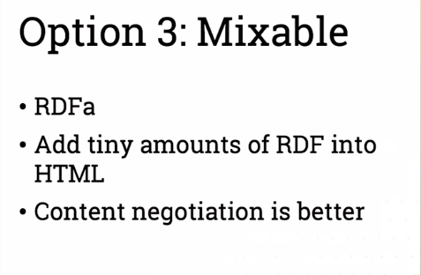

## Graphs

## web ontologies

Sub property

 Declare equivalent properties in equivalent classes so that again, a reasoning system operating over this can choose to use whichever vocabulary gives it information at a given time.

## Triplestores and SPARQL

Anything with a question mark in it is just a named variable.

Returns the name

+ => so foaf knows plus frontier means connect David to this variable by as many chains of knows as you want.

Federated query - create one query that addresses multiple sparkle endpoints so that a query going to Wikidata can also have an element joined with elements from a library, sparkle endpoint, or some other commercial organizations' sparkle endpoint or something local to us

